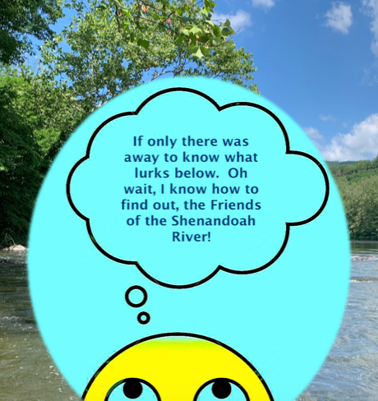
You may have seen the recent article, “Environmental group: Use Shenandoah River with caution” by Mickey Powell in the Winchester Star. According to the article, one should think twice before jumping in the Shenandoah River to cool off. For the past four summers the Friends of the Shenandoah River have been measuring E. coli levels at public access sites along the Shenandoah River. Soon after the E. coli results are determined, we make this information available to all via our website, www.fosr.org, and our Facebook page, https://www.facebook.com/profile.php?id=100015330303150

We have been providing this accredited E. coli data to you so that you can make an informed decision of the potential related health risks before engaging in primary recreational use activities in the river.

Only with YOUR SUPPORT can the Friends of the Shenandoah River continue to provide this vital service. Please support us by making a donation today. http://fosr.org/join-us/join/

